
FACULTY OF TECHNOLOGY AND ENGINEERING
DEVANG PATEL INSTITUTE OF ADVANCE TECHNOLOGY
AND RESEARCH

DEPARTMENT OF COMPUTER ENGINEERING

A.Y 2026 – 27 Semester – 3

LAB MANUAL

CSUC201 Fundamentals of Data Structures and Algorithms

Practical 5: Doubly Linked List and Circular Linked List Operations
Practical Aim :
To implement core doubly linked list and circular linked list operations and understand how bidirectional and circular linking change the way nodes are inserted, deleted, and traversed.
Problem 1 :
A music player maintains a playlist where songs can be added to the beginning, added to the end, or inserted right after a specific song that is currently playing. When a song is removed, only the first song in the playlist is dropped. At any point the player can count how many songs are in the playlist and display them from first to last. Given a sequence of such operations, implement all of them on a doubly linked playlist and print the result after each operation. Describe how your insertion after a given song works. What extra step does a doubly linked list require here that a singly linked list did not? What happens if the given song is not found in the playlist?
For Code :

https://github.com/kvvaghasiya49/FDSA/tree/6fb2f463bf1f58ac 408ada5ca8ffdaa64bc82087/DSA

Output:
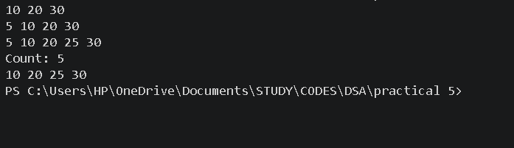

Problem 2 :
A group of students are sitting in a circle playing a passing game. A token starts at the first student and is passed around the circle one student at a time. Students can join the circle at any position and leave at any time, and the circle must remain unbroken after every join or leave. Given a sequence of join, leave, and display operations, implement them on both a singly circular and a doubly circular linked list and print the current circle after each operation. Describe how your solution ensures the circle stays unbroken after a student leaves. What is the one case where breaking the circle is most likely to happen as a bug, and how did you handle it?
For Code :

https://github.com/kvvaghasiya49/FDSA/tree/6fb2f463bf1f58ac 408ada5ca8ffdaa64bc82087/DSA

Output :

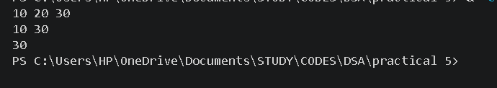

Challenges Faced:
In the doubly linked playlist, the hardest part was inserting a song after a given song. Each node has two links, so I had to update four pointers (next and prev of the new node, next of the given song, and prev of the song after it), and the order mattered. When I changed them in the wrong order, the list broke. I also had to check that the given song exists, and handle the case where it is the last song, because then there is no next node whose prev can be changed. While removing the first song, I forgot at first to set the prev of the new first node to NULL, which left it pointing at a deleted node

Learning Outcomes:
- I learned how to insert and delete in a doubly linked list by updating both the next and prev links in the correct order.
- I understood that a doubly linked list needs extra care compared to a singly linked list, because every change has to be reflected in two directions.
- I learned that a circular list has no NULL at the end, so traversal must stop when we return to the starting node.
- I learned that edge cases like an empty list, a single node, removing the first or last node, and a song not found must be handled separately to avoid bugs and broken circles.

1.A doubly linked list maintains two links per node instead of one. When deleting the front node, explain why having a backward link on the second node creates a responsibility that did not exist in a singly linked list — and what goes wrong if you forget to handle it.
Ans :
In a doubly linked list, the second node has a prev pointer that points to the first node. When the first node is deleted, the head moves to the second node, but that node's prev pointer still points to the deleted node. So the responsibility is to set the prev of the new first node to NULL. In a singly linked list, no node points backward, so only the head has to move.
If I forget this, the new first node keeps a dangling pointer to memory that has already been freed. Moving backward from it, or any later operation that uses prev, can crash the program or give wrong output.

2.If your traversal of the circular list does not stop at the right moment, it will loop forever. Without referencing any specific code, explain what condition must be true at the moment you stop, and why that condition would fail if you set the last node's link to null.
Ans :
The traversal must stop at the moment the current node becomes the same as the starting node again, which means we have gone around the circle exactly once. In a circular list, the last node links back to the first node, so this condition is always reached.
If the last node's link were set to NULL, the list would no longer be circular. The current node would never come back to the starting node, so the stopping condition would never become true. Instead, the current pointer would become NULL, and using it would crash the program.

Remark :

